Building a Submarine
http://inventors.about.com/od/lessonplans/ss/submarine_build.htm

Materials:
- Empty 16 or 20 ounce bottle with a hole in the cap (the hole must be big enough to pass a flexible straw through)
- Three wide rubber bands
- 24 pennies
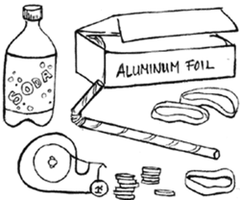
- Aluminum foil
- Adhesive tape
- Flexible Straw
- Large tub of Water

Procedure:
- Cut 3 holes in the side of the soda bottle
- Stack pennies into piles of 4, 8, and 12
- carefully wrap stacks of pennies with foil
- Place a rubber band around the plastic bottle and slide it next to the closest hole. Position the other rubber bands next to the 2 remaining holes.
- Place the four-penny stack under the rubber band closest to the bottles top.
- Place the 8-penny stack under the middle rubber band next to the middle hole.
- Place the 12-penny under the last rubber band (the weights should be next to the holes not over them)
- Push the shorter end of the straw (about one each) through the hole in the bottles cap. Reattach the bottle cap to the bottle. Keep the flex section outside and bent upwards. Tape straw securely into place in bottle cap.
- Lower the “submarine” into the water. Do not let the long end of the straw take in water.
- Observe the action of the “sub” and record your observations.
- When the sub stops sinking, blow into the straw.
- Observe the actions and record your observations.
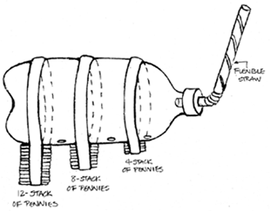

Name ____________________________ Date ______________________

1. What makes your submarine sink? _______________________________

_____________________________________________________________________

_____________________________________________________________________

2. What makes it surface? ________________________________________

______________________________________________________________

______________________________________________________________

3. Now you know the basic properties that make a submarine dive and surface. What is your soda bottle missing that real submarines have to navigate underwater? (Think of your sub as an underwater airplane)

______________________________________________________________

______________________________________________________________

______________________________________________________________

______________________________________________________________

______________________________________________________________

